# 

# Assignment_3

**Prepared by:**

Name of Student : Chaitanya Dalvi

Roll No: 19

Batch: 2023-27

Dept. of CSE

*1.what is join?Explain types of join ?Demonstrate any one example .*

*2.what is subqueries?Explain its types and Demonstrate any one example.*

*3.What is view?explain in detail?*

*4.what is Trigger and stored procedure explain in detail?*

**1.what is join?Explain types of join ?Demonstrate any one example**

**Ans:-**

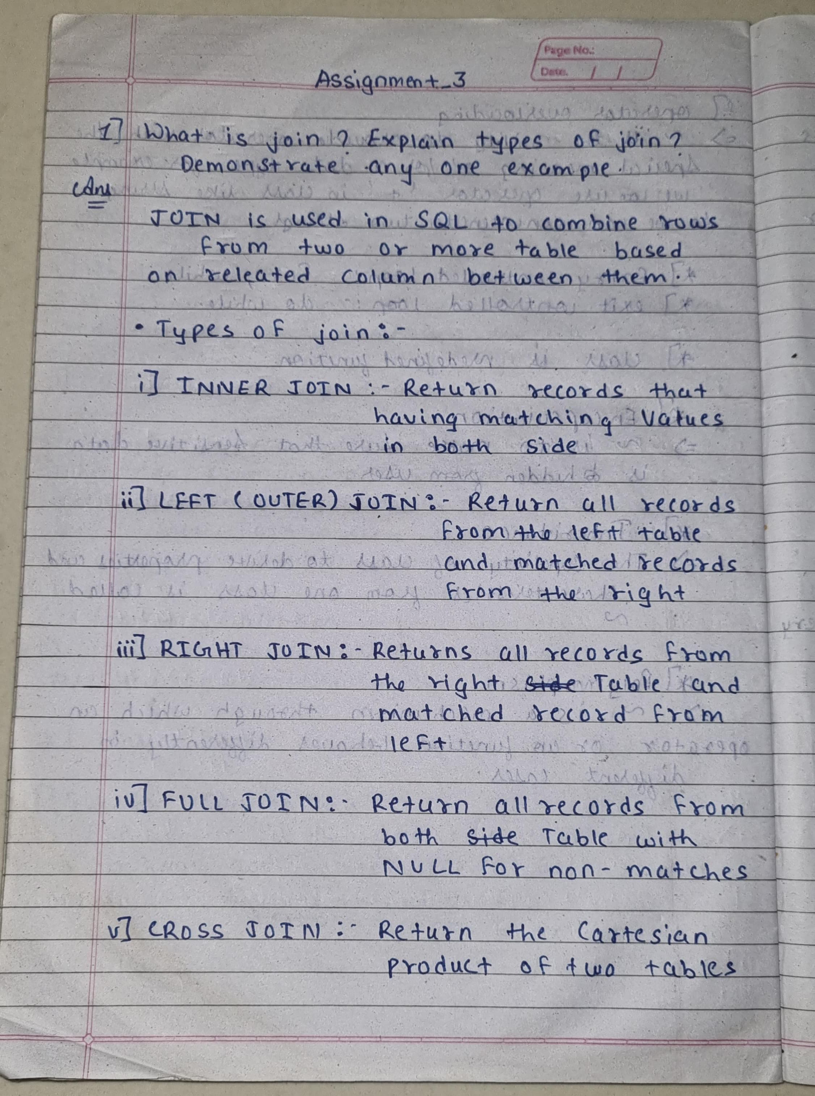

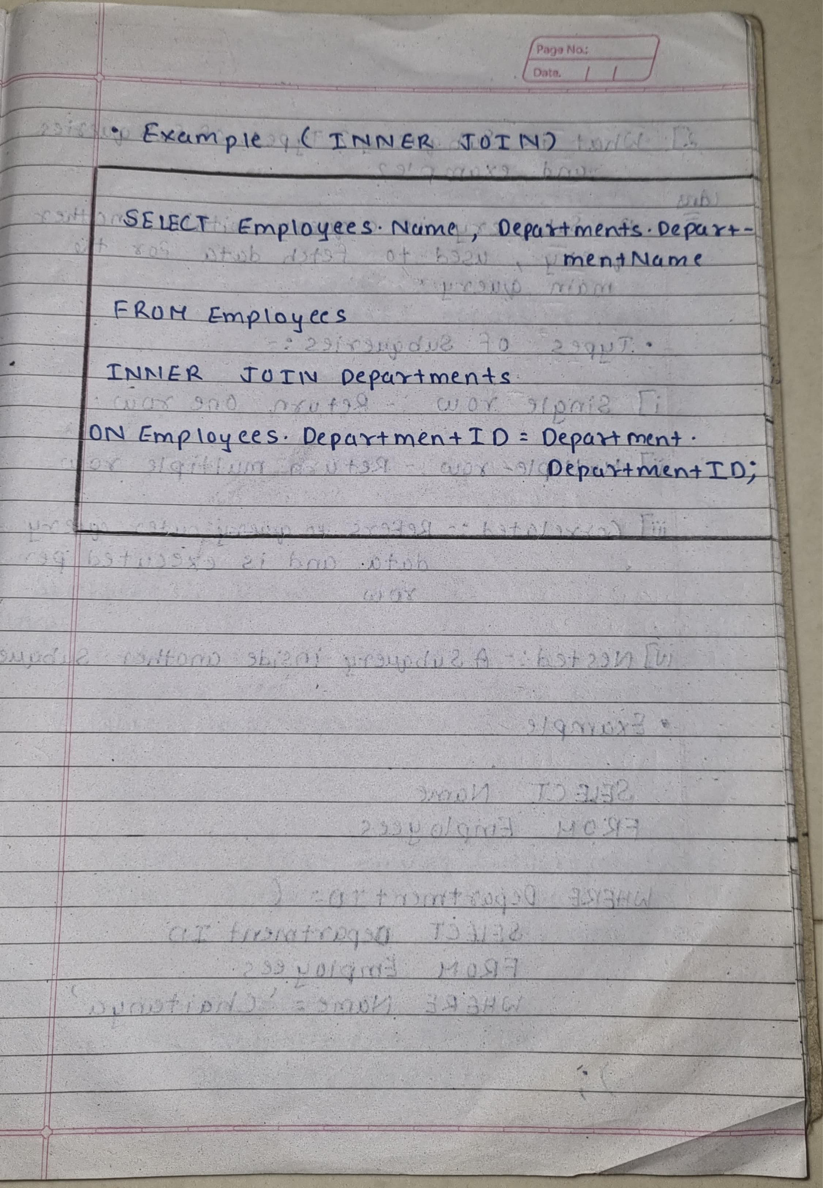

**2.what is subqueries?Explain its types and Demonstrate any one example.**

**Ans:-**

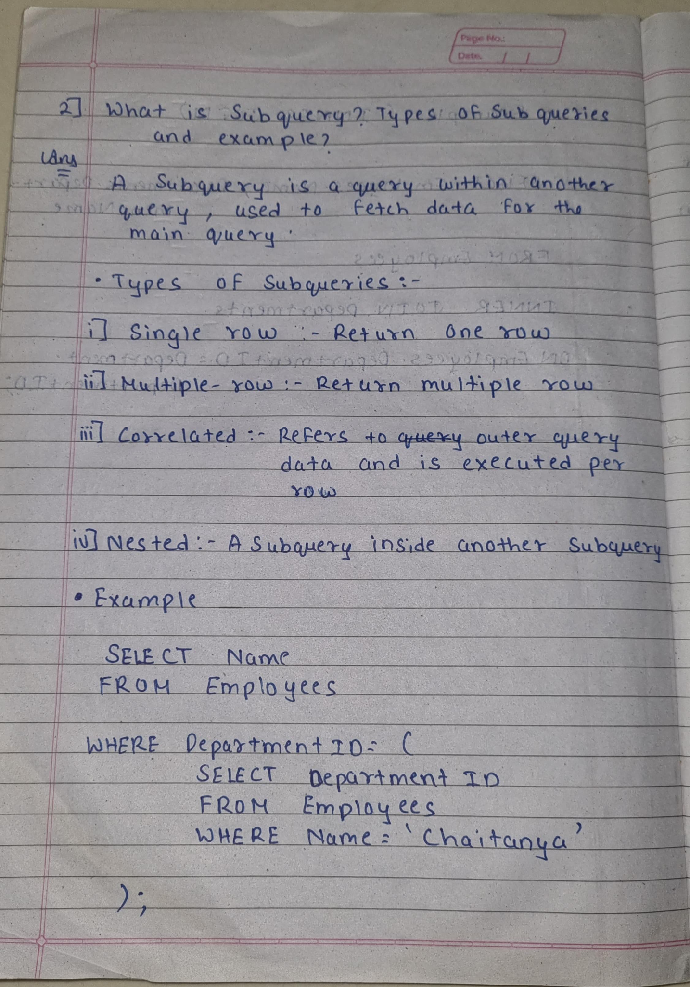

**3.What is view?explain in detail?**

**Ans:-**

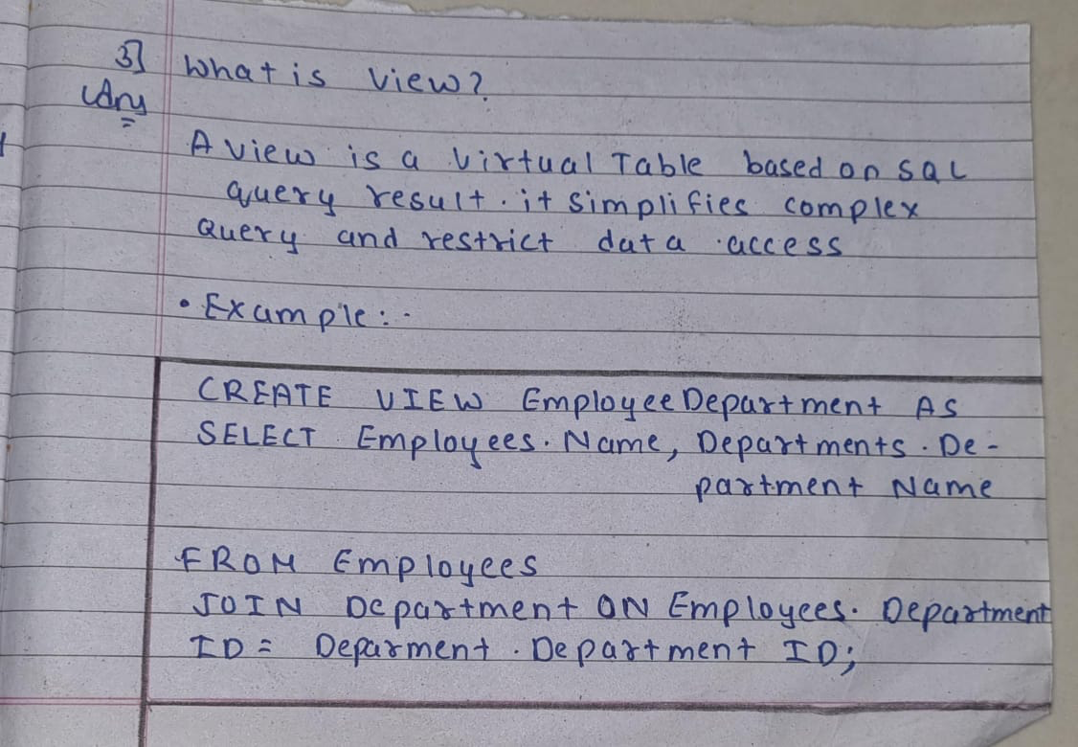

**4.what is Trigger and stored procedure explain in detail?**

**Ans:-**

